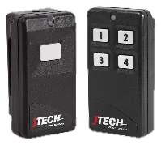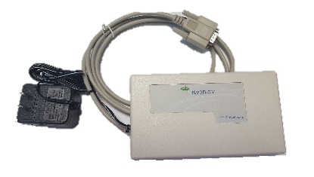Components

**2.**

1. 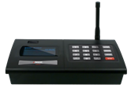ISTATION Transmitter (with power supply & antenna)

**4.**

1. ES Push Button Receiver (with power supply)
2. 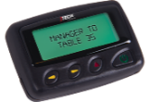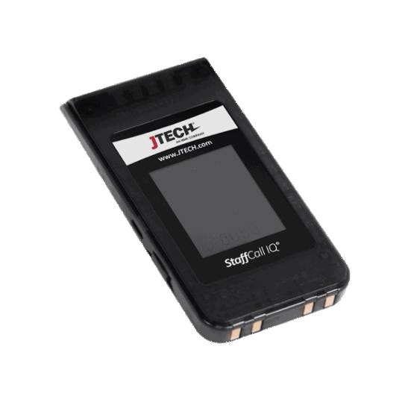Alpha Pagers (RALPHA & STFIQ)

**3.**

**1.**

1. ES Push Button

Equipment Setup

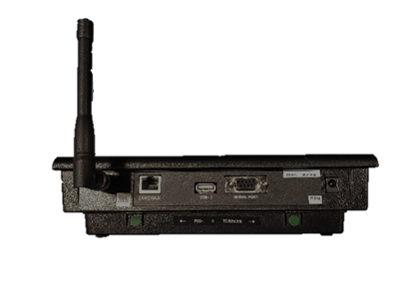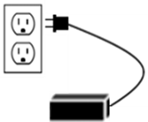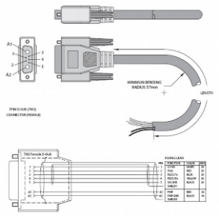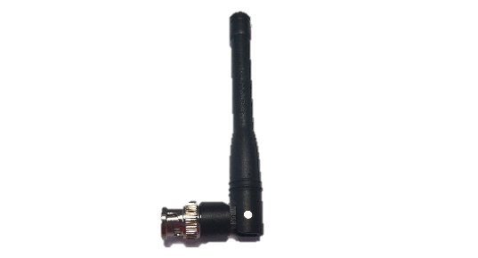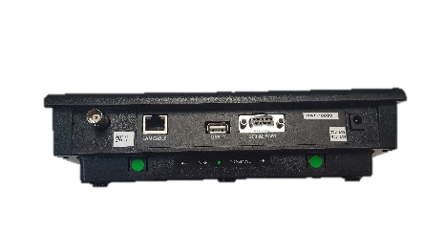

|  |  |  |
| --- | --- | --- |
|  |  |  |
| **Step 1** Connect the antenna to the transmitter. Twist to lock in place. | **Step 2** Connect the ES Receiver serial cable to the serial port on the back of the ISTATION and then tighten the screws. | **Step 3** Plug the ES Receiver power supply into a standard 110-240v outlet. **A surge protector is recommended.** |

|  |  |  |  |
| --- | --- | --- | --- |
|  |  |  | |
| **Step 4** Plug the power supply into the transmitter and then into a standard 110-240v outlet. **A surge protector is recommended.** | **Step 5 – RALPHA**  On the back, push the clear lock up to unlock the battery cover. Slide the battery cover off. Once opened, insert battery. Slide the cover back on and push the clear lock down to secure the battery cover in place. | **Step 5 – STFIQ**  Plug the power supply into the charging base and then into a standard 110-240v outlet. Insert all pagers into the charging base. | **Step 5 – STFIQ**  **OPTIONAL:**  Plug the cable into a USB port and then plug the Micro USB into the side of the pager. |

Push Button Installation

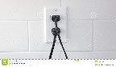

ES Receiver

### **Installing the Receiver:**

* 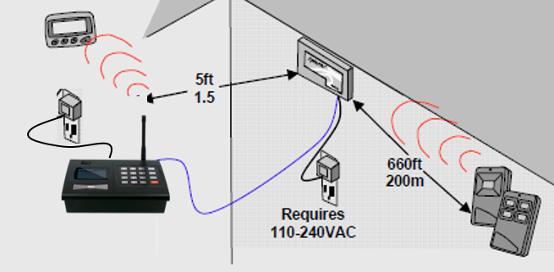Mount the ES Receiver within 660 ft (200m) of the Push Button Transmitters.

5 ft.

* The best mounting location for the ES Receiver is near the ceiling or as high as possible.

ISTATION

* Mount the ES Receiver at least 5ft (1.5m) from the ISTATION using the supplied 10ft (3m) cable.
* Walls, pipes, ducts, mirrored glass, etc. blocking the transmission path may reduce range.
* The ES Receiver does not use an external Antenna.
* Requires 110-240v AC outlet for power.

### **Range Test Push Button Transmitters:**

1. Hold a Push Button Transmitter in one hand and a corresponding Pager in the other.
2. Stand at least 5ft (1.5m) from the Receiver.
3. Start walking away from the receiver slowly and push the button on the Push Button Transmitter to send a message. Check to see if you have received the page.
4. Continue to walk away from the receiver and press the button every 10-15 seconds until the pager no longer receives a page.
5. Back up slowly and retry until the Pager again receives the page.
6. That point marks the maximum range of the Push Button Transmitter in that direction.
7. Repeat for all directions as needed.
8. Push Button Transmitter to ISTATION range can be extended by adding one or more Repeaters.

System Operation

### **Handing out the pagers:**

Give the staff member a pager. Tell the staff member the pager will signal when they are needed. The default page for this system is for the pager to vibrate for 8 seconds. After the pager is finished vibrating it automatically goes back into standby mode waiting for the next page. You can give the pagers out directly from the charging base (they will “demo” page each time they are removed from the charging base) or you can simply store them in a basket and hand them out. A fully charged pager will function for a full day without being recharged.

### **Paging the staff member:**

To send an alert, press a button on the ES Push Button corresponding with the pager. The default message for this button will display on the pager.